FINTRAC Acceptable Identification Cards & Documents
The use of personal information in Canadian commercial activities is protected by the Personal Information Protection and Electronic Documents Act (PIPEDA), or by similar provincial legislation. You have to inform clients about the collection of their personal information. However, you do not have to inform them when you include their personal information in the reports you are required to submit to FINTRAC.
The following list provides examples of acceptable government-issued photo identification documents from federal, provincial or territorial authorities. This is not an exhaustive list, verify with your Compliance Officer to confirm acceptability of cards or documents not listed here.
Note: You cannot use a provincial health card for identification purposes where it is prohibited by provincial legislation to use the card as a form of identification or to record the health card number.
*ID design, format and layout are subject to change. Samples provided are for reference only. Direct any questions or concerns to the Compliance Officer.
Source: https://fintrac-canafe.canada.ca/guidance-directives/client-clientele/Guide11/11-eng#annex4
Type of card or document | Issuing province or state and country | Sample
Canadian passport | Canada | 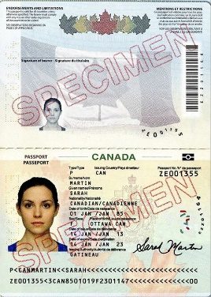  New version:  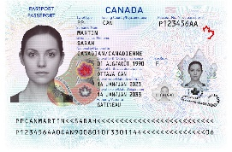
Permanent resident card | Canada | 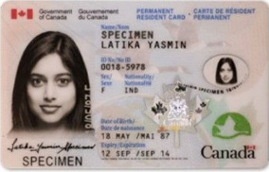
Citizenship card (issued prior to 2012) | Canada | 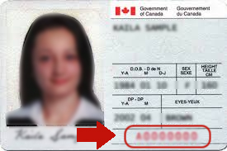
Secure Certificate of Indian Status | Canada | 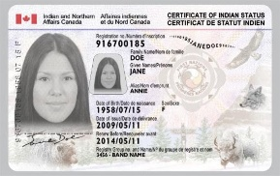
Driver’s Licences
British Columbia Driver's Licence | British Columbia, Canada | 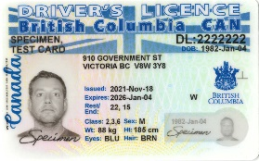
Alberta Driver's Licence | Alberta, Canada | 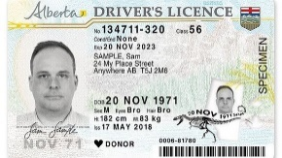
Saskatchewan Driver's Licence | Saskatchewan, Canada | 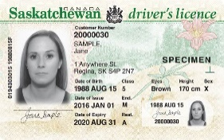
Manitoba Driver's Licence | Manitoba, Canada | 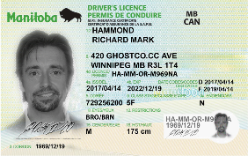
Ontario Driver's Licence | Ontario, Canada | 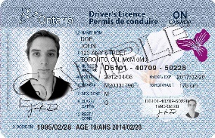  New version:  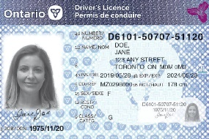
Québec Driver's Licence | Québec, Canada | 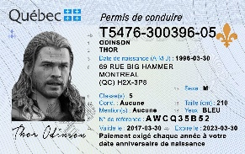
New Brunswick Driver's Licence | New Brunswick, Canada | 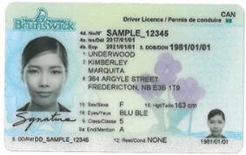
Nova Scotia Driver's Licence | Nova Scotia, Canada | 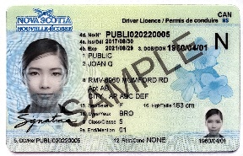
Prince Edward Island Driver's Licence | Prince Edward Island, Canada | 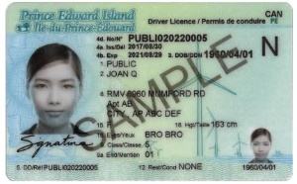
Newfoundland and Labrador Driver's Licence | Newfoundland and Labrador, Canada | 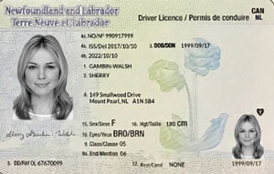
Yukon Driver's Licence | Yukon, Canada | 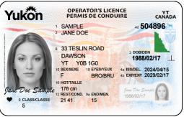
Northwest Territories Driver's Licence | Northwest Territories, Canada | 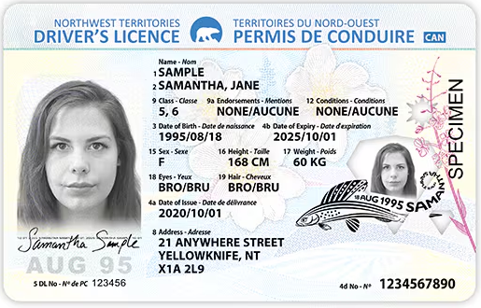
Nunavut Driver's Licence | Nunavut, Canada | 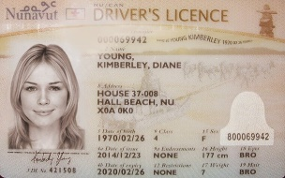
DND 404 Driver's Licence | Department of National Defence, Canada | 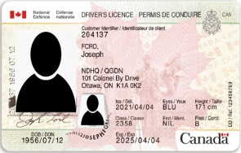
Provincial services cards
British Columbia Services Card | British Columbia, Canada | 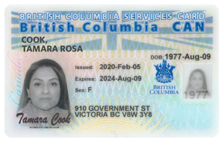
Provincial or territorial identity cards
Alberta Photo Identification Card | Alberta, Canada | 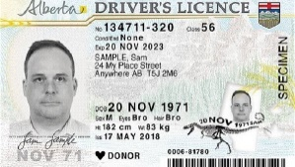
Saskatchewan Non-driver photo ID | Saskatchewan, Canada | 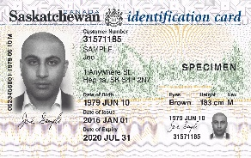
Manitoba Enhanced Identification Card | Manitoba, Canada | 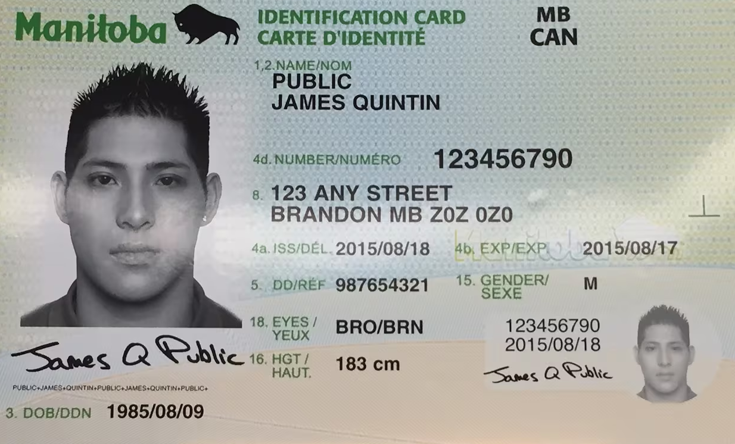
Ontario Photo Card | Ontario, Canada | 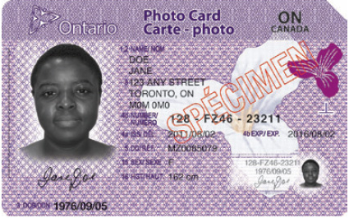
New Brunswick Photo ID Card | New Brunswick, Canada | 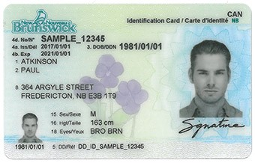
Nova Scotia Identification Card | Nova Scotia, Canada | 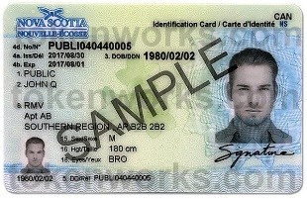
Prince Edward Island Voluntary ID | Prince Edward Island, Canada | 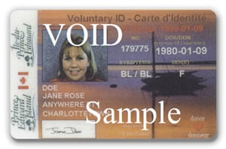
Newfoundland and Labrador Photo Identification Card | Newfoundland and Labrador, Canada
Northwest Territories General Identification Card | Northwest Territories, Canada | 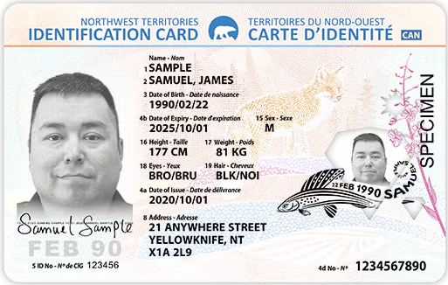
Nunavut General Identification Card | Nunavut, Canada
Types of card or international document
Global Entry Card | United States | 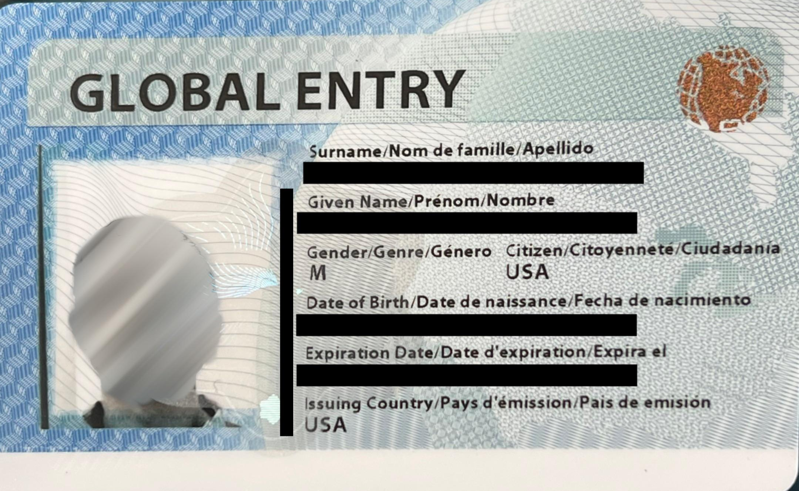
NEXUS | United States or Canada | 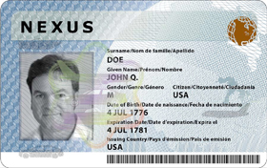
International Driver’s License | Various | 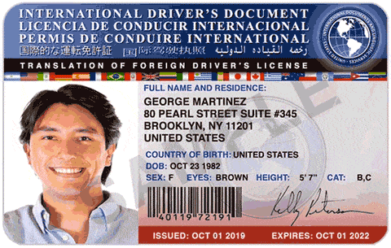

Examples of reliable sources of information
This is not an exhaustive list. You must always rely on valid and current information, whether it be through an original version or whether you obtain another version of the information's original format, such as a fax, photocopy, scan, or electronic image, and that can meet your related record keeping obligations.
Reliable sources of information to verify name and address
Issued by a Canadian government body:
- A fax, photocopy, scan or electronic image of a government-issued photo identification document
- Any statement, form, certificate or other source issued by a Canadian government body (federal, provincial, territorial or municipal):
- Canada Pension Plan (CPP) statement
- Property tax assessment issued by a municipality
- Provincially issued vehicle registration
- Benefits statement:
- Federal, provincial, territorial, or municipal levels

Issued by other Canadian sources:
- Utility bill (for example, electricity, water, telecommunications)
- Canada 411
- Record of Employment
- Registered investment account statements (for example, RRSP, TFSA or RRIF)
- Canadian credit file that has been in existence for at least three (3) years
- Product from a Canadian credit bureau (containing two trade lines in existence for at least three (3) years)
- Insurance documents (home, auto, life)
- For a currently enrolled student, a transcript or documentation issued by a school that contains a unique reference number

Reliable sources of information to verify name and date of birth
Issued by a Canadian government body:
- A fax, photocopy, scan or electronic image of a government-issued photo identification document
- Any statement, form, certificate or other source issued by a Canadian government body (federal, provincial, territorial or municipal):
- Birth certificate
- Marriage certificate or government-issued proof of marriage document (long form which includes date of birth)
- Divorce documentation
- Permanent resident card
- Citizenship certificate
- Temporary driver's licence (non-photo)

Issued by other Canadian sources:
- Canadian credit file that has been in existence for at least three (3) years
- Product from a Canadian credit bureau (containing two trade lines in existence for at least three (3) years)
- Investment account statements (for example, RRSP, GIC)
- Insurance documents (home, auto, life)

Issued by a foreign government:
- Travel visa
- A fax, photocopy, scan or electronic image of a photo identification document issued by a foreign federal, provincial or territorial government (for example, foreign driver's licence or passport)

Reliable sources of information to verify name and confirm a financial account (specifically, a deposit account, prepaid payment product account, credit card account or loan account)
Confirm that the person has a deposit account, prepaid payment product account, credit card or loan account by means of:
- Credit card statement
- Bank statement for deposit or chequing accounts
- Loan account statement (for example, mortgage)
- Cheque that has been processed in the last statement period (cleared, insufficient funds) by a financial institution
- Telephone call, email, letter, or other traceable means of confirmation from the financial entity holding the deposit account, prepaid payment product account, credit card or loan account
- Product from a Canadian credit bureau (containing two trade lines in existence for at least three (3) years)
- Use of micro-deposits

